To start using the Flexbox model, you need to first define a flex container.

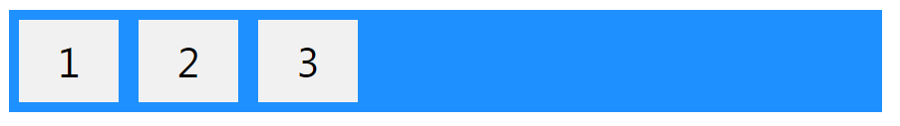

The element above represents a flex container (the blue area) with three flex items.

**<style>**

**.flex-container {**

**display: flex;**

**background-color: DodgerBlue;**

**}**

**.flex-container > div {**

**background-color: #f1f1f1;**

**margin: 10px;**

**padding: 20px;**

**font-size: 30px;**

**}**

**</style>**

The flex container properties are:

1. [flex-direction](https://www.w3schools.com/css/css3_flexbox.asp#flex-direction)
2. [flex-wrap](https://www.w3schools.com/css/css3_flexbox.asp#flex-wrap)
3. [flex-flow](https://www.w3schools.com/css/css3_flexbox.asp#flex-flow)
4. [justify-content](https://www.w3schools.com/css/css3_flexbox.asp#justify-content)
5. [align-items](https://www.w3schools.com/css/css3_flexbox.asp#align-items)
6. [align-content](https://www.w3schools.com/css/css3_flexbox.asp#align-content)

[**flex-direction**](https://www.w3schools.com/css/css3_flexbox.asp#flex-direction)

The flex-direction property defines in which direction the container wants to stack the flex items.

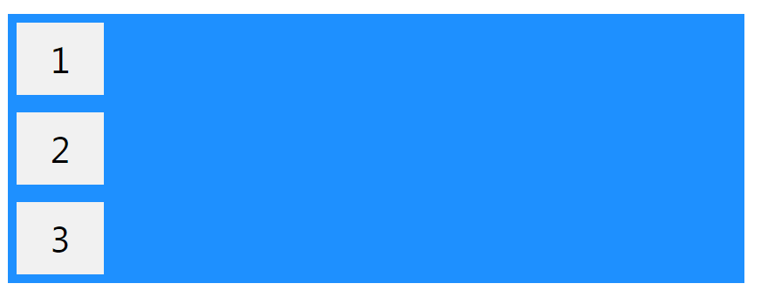

Example

The column value stacks the flex items vertically (from top to bottom):

**.flex-container {**

**display: flex;**

**flex-direction: column;**

**}**

Example

The column-reverse value stacks the flex items vertically (but from bottom to top):

.**flex-container {**

**display: flex;**

**flex-direction: column-reverse;**

**}**

Example

The row value stacks the flex items horizontally (from left to right):

**.flex-container {**

**display: flex;**

**flex-direction: row;**

**}**

Example

The row-reverse value stacks the flex items horizontally (but from right to left):

**.flex-container {**

**display: flex;**

**flex-direction: row-reverse;**

**}**

## The flex-wrap Property

The flex-wrap property specifies whether the flex items should wrap or not.

The examples below have 12 flex items, to better demonstrate the flex-wrap property.

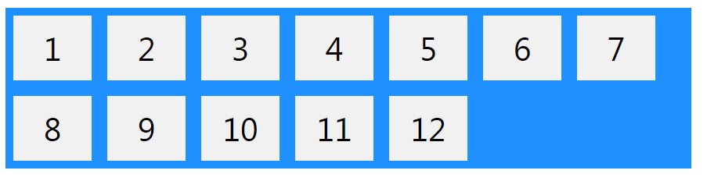

Example

The wrap value specifies that the flex items will wrap if necessary:

**.flex-container {**

**display: flex;**

**flex-wrap: wrap;**

**}**

Example

The nowrap value specifies that the flex items will not wrap (this is default):

**.flex-container {**

**display: flex;**

**flex-wrap: nowrap;**

**}**

Example

The wrap-reverse value specifies that the flexible items will wrap if necessary, in reverse order:

**.flex-container {**

**display: flex;**

**flex-wrap: wrap-reverse;**

**}**

## The justify-content Property

The justify-content property is used to align the flex items:



Example

The center value aligns the flex items at the center of the container:

**.flex-container {**

**display: flex;**

**justify-content: center;**

**}**

Example

The flex-start value aligns the flex items at the beginning of the container (this is default):

**.flex-container {**

**display: flex;**

**justify-content: flex-start;**

**}**

Example

The flex-end value aligns the flex items at the end of the container:

**.flex-container {**

**display: flex;**

**justify-content: flex-end;**

**}**

Example

The space-around value displays the flex items with space before, between, and after the lines:

**.flex-container {**

**display: flex;**

**justify-content: space-around;**

**}**

Example

The space-between value displays the flex items with space between the lines:

**.flex-container {**

**display: flex;**

**justify-content: space-between;**

**}**

## The align-items Property

The align-items property is used to align the flex items vertically.

In these examples we use a 200 pixels high container, to better demonstrate the align-items property.

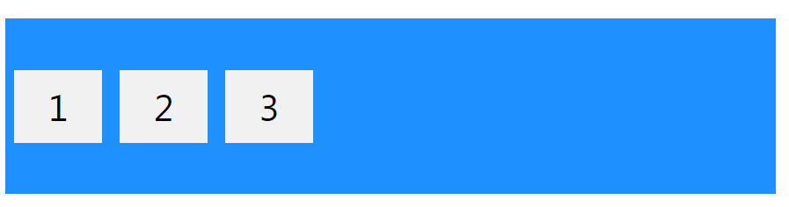

Example

The center value aligns the flex items in the middle of the container:

**.flex-container {**

**display: flex;**

**height: 200px;**

**align-items: center;**

**}**

Example

The flex-start value aligns the flex items at the top of the container:

**.flex-container {**

**display: flex;**

**height: 200px;**

**align-items: flex-start;**

**}**

Example

The flex-end value aligns the flex items at the bottom of the container:

**.flex-container {**

**display: flex;**

**height: 200px;**

**align-items: flex-end;**

**}**

Example

The stretch value stretches the flex items to fill the container (this is default):

**.flex-container {**

**display: flex;**

**height: 200px;**

**align-items: stretch;**

**}**

Example

The baseline value aligns the flex items such as their baselines aligns:

**.flex-container {**

**display: flex;**

**height: 200px;**

**align-items: baseline;**

**}**